In order to use these opencv programs

you will need to

1 Install Python 3.6 and PyCharm. Follow this [tutorial](https://basecamp.robolink.com/cwists/preview/3296x).

2 Open PyCharm and create a new project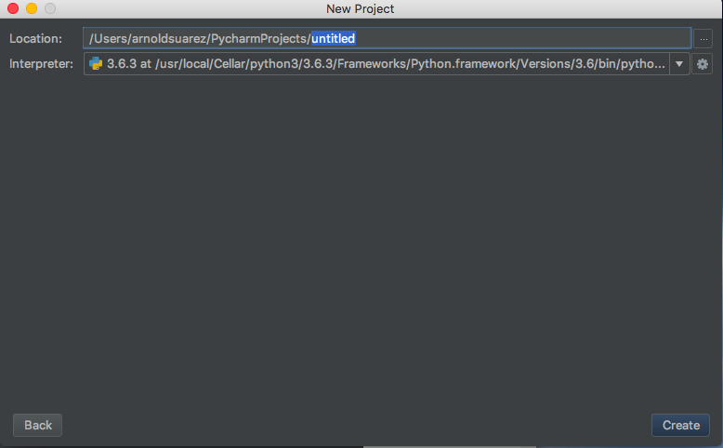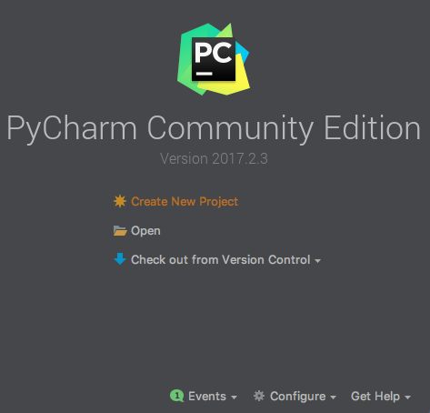

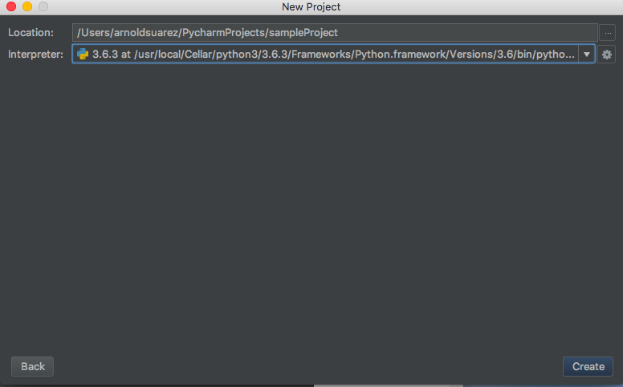

Give the project a name this one will be named

“sampleProject”

Make sure to select the Python intrepeter (What python version you want to pick)

Tip make sure it is not the virtual enviroment one (venv).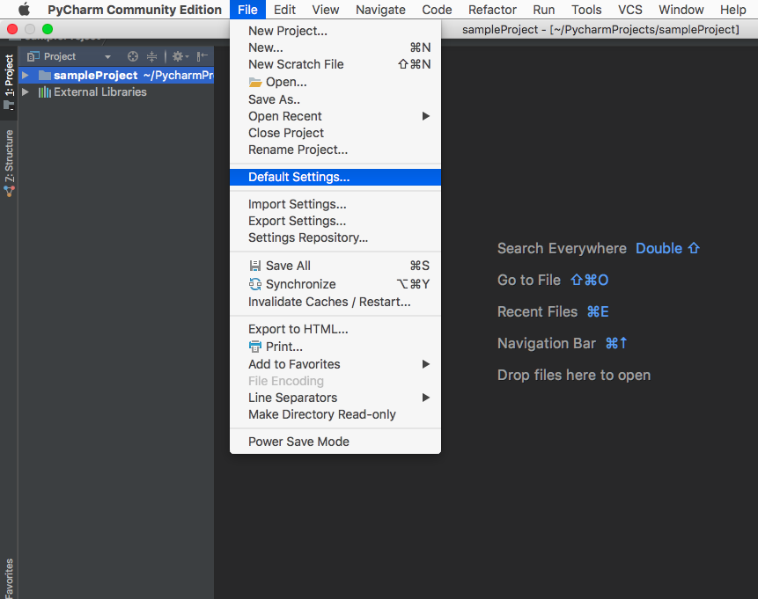

4 Now get to default settings

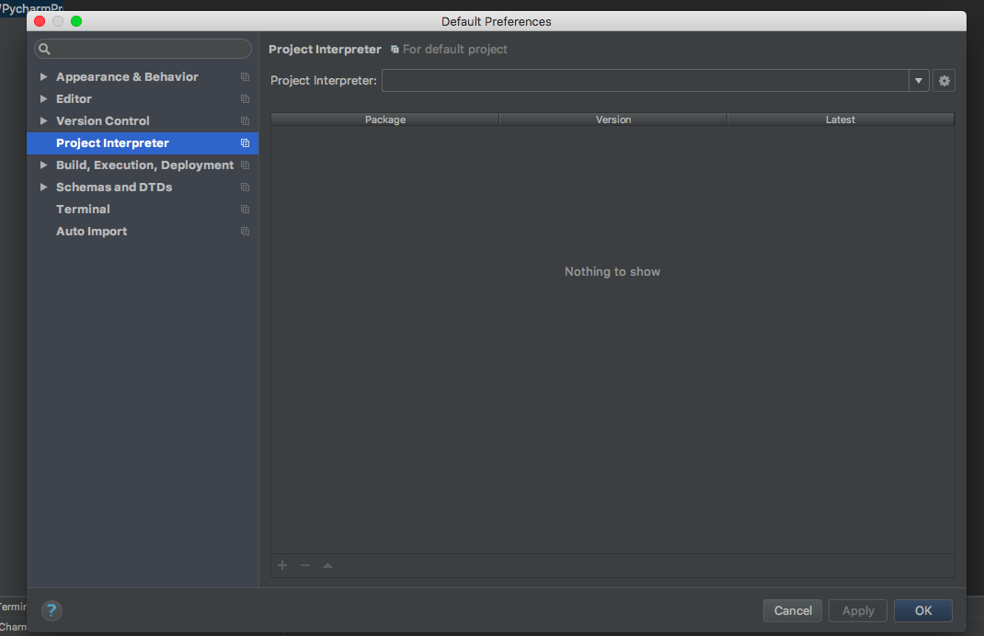

5 Now Select the project interpreter and select python 3.6

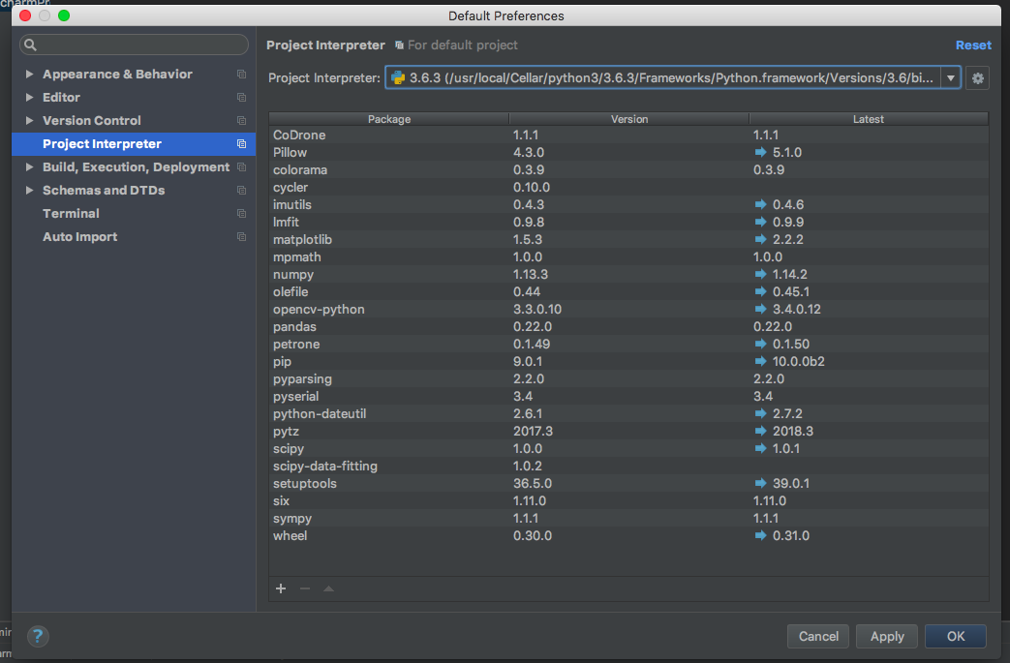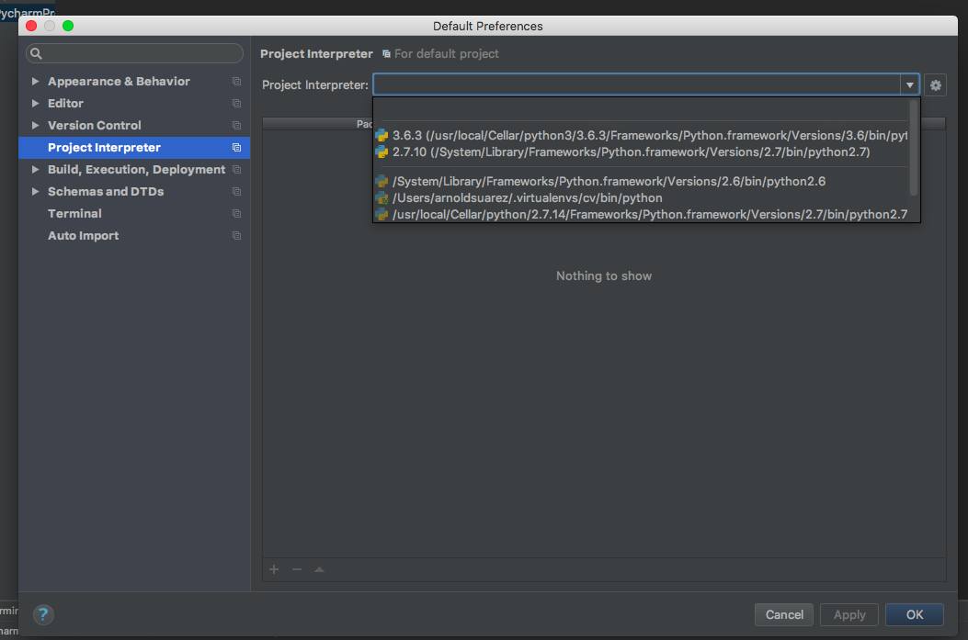

6 Once you have selected it click the plus icon on

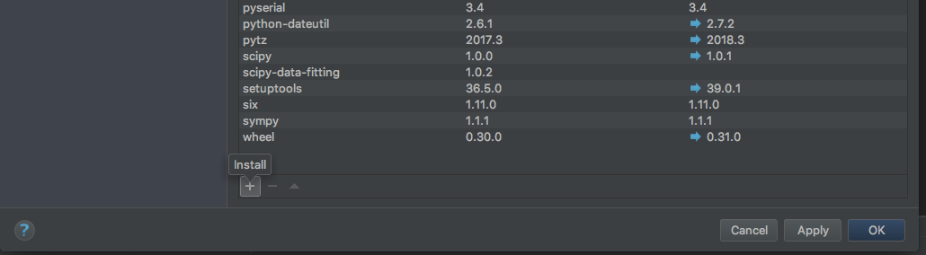

the left bottom.

This will open up the library manager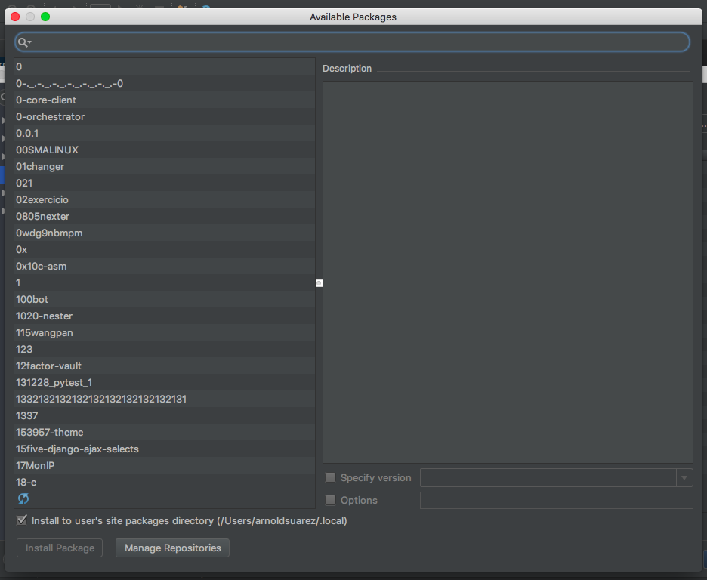

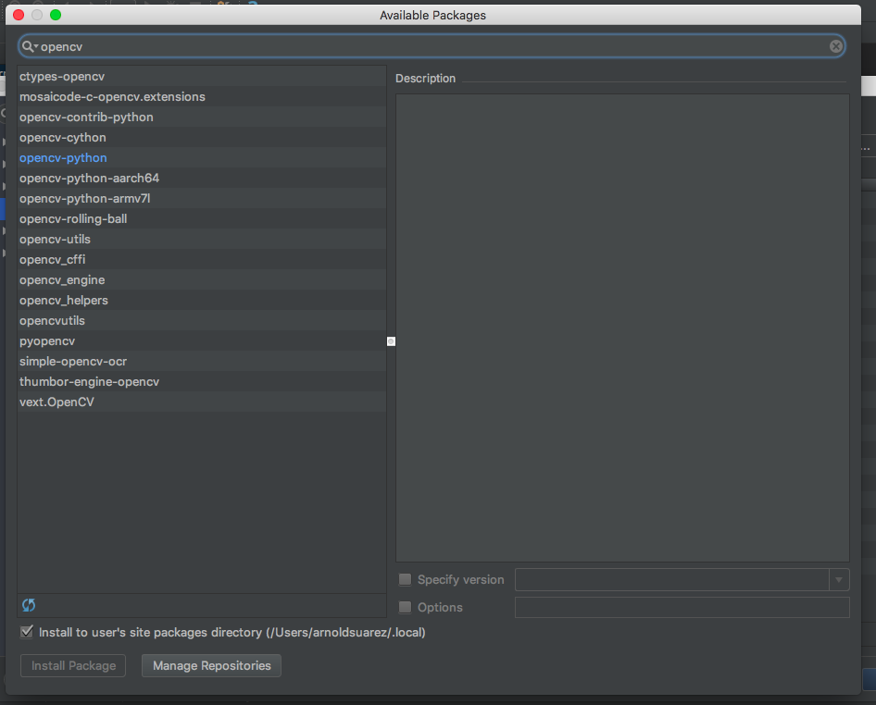

Look for opencv-python

Now select install package and wait till it turns green.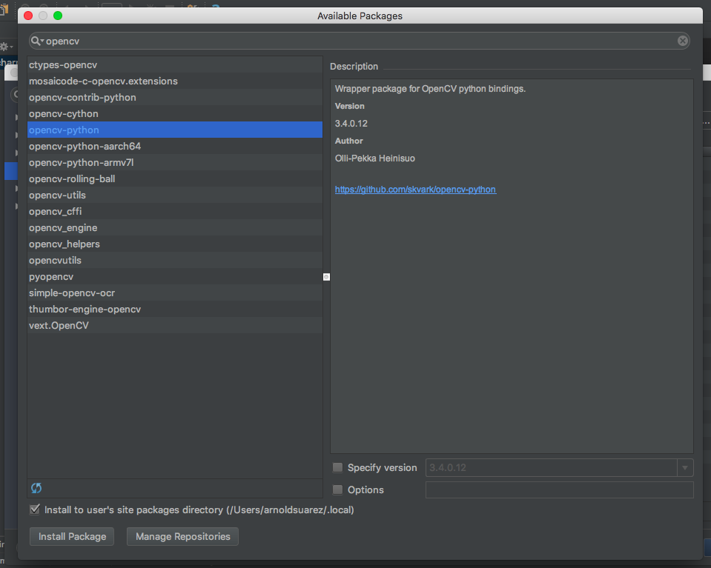

Like this

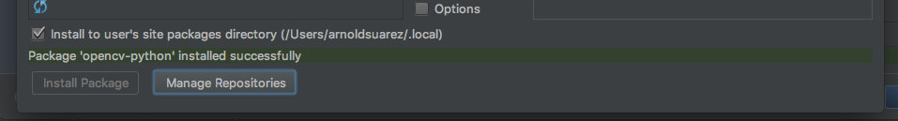

Now you can click apply and then ok.

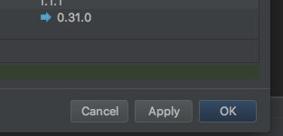

Now you can start using the sample programs